COMMISSIONING IN 2008-2009-THE BUSINESS CALENDAR
Presenter at Board meeting: Peter Jones

Purpose of Paper: To brief the board on the commissioning process timetable for 2008-2009

Assurance Framework Objective:
4 Effective commissioning -Become effective commissioners; develop a performance culture with Smart productivity metrics and deliver the six must do targets

Action Required by Board:

The Board is asked to:
- Note the commissioning process timetable and the business calendar it is derived from.
- Receive a report in January 2008 on the commissioning progress

Key areas for discussion or noting:
- The paper outlines the commissioning process timetable for 2008-09 and encloses the business calendar from which it is derived and
- Notes the major elements which contribute to the formulation of the advance warning of commissioning intentions which will be sent to providers
- Key factors influencing activity changes are highlighted

Peter Jones
Interim Director of Commissioning
19 November 2007

East and North Hertfordshire Primary Care Trust
West Hertfordshire Primary Care Trust
COMMISSIONING IN 2008-2009-THE BUSINESS CALENDAR

Introduction
Late autumn sees the beginning of planning for commissioning of care services. Before agreements can be finalised the PCT must take into account the complex interplay of national guidance; joint commissioning initiatives and the strategic imperative to move specification of services to primary care.
In order to ensure that the major elements contributing to service provision are taken into account the Executive has drafted a business calendar that itemises steps to be taken by calendar month. It is a work in progress but is guiding the commissioning process. An outline example is attached at enclosure 1.

Commissioning Intentions
Commissioning intentions are to be issued in December of the year before they commence. They are a simple statement, without detail, and are intended to provide advance warning of any changes of requirements. They derived from key elements which include, amongst others:
- Month 6 figures upon which to base out turn predictions
- Annual Health Check findings
- Draft of National operating frameworks (including targets) and contract templates (Department of Health briefings)
- Public health Needs assessment
- Practice based groups intentions
- PCT local priorities
- Choice

Commissioned Activity-forecasting the figures
It is not possible to accurately forecast activity figures before the end of January. These will be based upon the out turn but will be adjusted for the effects of various factors (some of which are illustrated in Enclosure 2) which include:
- PBC Service changes agreed by the governance committee ( the approval process is attached at Enclosure 3)
- Implementation of the Acute Services review-first year including the procurement of intermediate care; the commissioning of the urgent care centres and other service changes with impacts on existing agreements
- Activity arising from national initiatives including 18 weeks access policy, Maternity matters and paediatric A&E provision
- Review of services arising from performance and/or capacity issues highlighted by improved access requirements
- Unbundling of block contracts particularly in diagnostics and walk in centres hosted by other PCTs where underlying activity is known to be higher than the existing block indicative figures.

Immediate Next Steps
The PCT will, by the end of November 2007:
- Brief the PBC groups on the national and local framework
- Submit end of year activity predictions to the SHA
- Finalise the population activity model reflecting gross activity variations s arising from known service and contracting changes

Recommendations
The Board is requested to:
- Note commissioning process timetable and the business calendar it is derived from.
- Receive a report on commissioning progress in January 2008
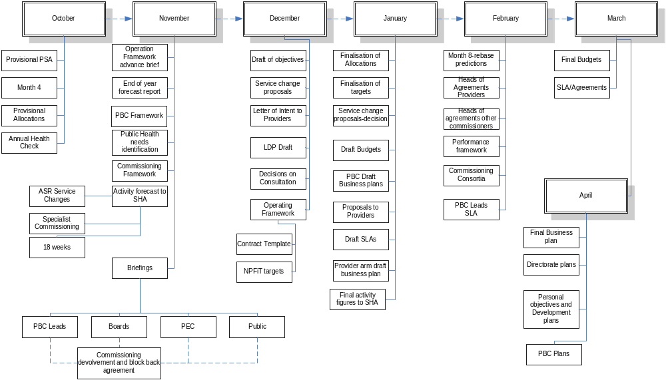 Enclosure 1 Enclosure 1 to Commissioning in 2008-2009-the Business Calendar

October
What | When | Lead
Provisional Allocations from NHS |  | DoF
Month 4 PBC Activity report |  | DDoC
Month 4 finalisation of costs |  | DoF
Production of Business activity Calendar |  | DoC
What | When | Lead
National Operating Framework Brief | 5th | DoF/DoC
End of year forecast | 21st | DoF
Public Health Needs identification | 21st | DPH
PBC framework | 23rd | DPC
PBC/PEC PCT operating framework-Briefings commence | 29th | DoC
ASR implementation impacts | 30th | DoS
Initial forecast of activity to SHA | 30th | DoC

November

December
What | When | Lead
Operating Framework; National Contract template; NpFit objectives | 10th | DoF/DoC/DoS
SHA Operating Framework | 15th | SHA
Draft of PCT Objectives | 22nd | DPPI&CS
Service Change proposals-PBC | 31st | DPC
Letter of intent to providers | 31st | DoC
Draft of LDP | 31st | DoC
Decisions on Service change Consultation | 31st | DoS
Second cut of activity figures to SHA | 31st | DoC

January
What | When | Lead
Business group (supporting service change proposals) convened | 5th | DoC
Finalisation of allocations by DoH | 15th | DoF
Template contract for non acute services from DoH | 15th | DoC
Provider Arm Draft Business plan | 15th | PS COO
PBC Governance group decisions on investment proposals | 21st | DPP&CS
Draft Budgets | 31st | DoF
PBC draft business plans | 31st | DPC
SLA/Contract/agreement Proposals to providers | 31st | DoC
Final activity figures | 31st | Doc

February
What | When | Lead
Month 8 rebase predictions | 10th | DoF/DoC
Heads of Agreement-Service providers | 28th | DoC
Consortia Agreements-between commissioning bodies | 28th | DoC
Implementation plans-PBC Change proposals (timing subject to legal restrictions on procurement etc) | 28th | DPC
Negotiating teams (including PBC Leads) Finalised | 28th | DoC/DPC
PCT finalisation of Objectives | 28th | DPP&CS
PCT Performance management framework | 28th | DoC

March/April
What | When | Lead
Final budgets | 15th M | DoF
SLA signed | 31st M | DoC
Final Business Plans PCT | 31st M | DoS
Final Business plan Provider | 10th A | PS COO
Final Business Plans PBC Groups | 10th A | DPC
Performance objectives allocated to Directors | 10th A | CE
Directorate Objectives & Plans | 21st A | Directors
Submit LDP | 7th A | DPP&CS

DoF=Director of Finance; DoC=Director of Commissioning (DDoC Deputy); DPC=Director of Primary Care and Service Redesign; DPP&CS=Director of Patient Public Involvement and Corporate Services
DoS=Director of Strategy; DPH=Director of Public Health; PS COO=Provider Services Chief operating Officer

Enclosure 2-Factors influencing Activity
Acute Contracts- Activity out turn 07/08
ASR
Demand management
Trends
Trends
CAS/CATS
Community Matrons
PBC Service changes
un Bundling
18 weeks
Conversion ratio
Coding changes
Reduce acute activity from predicted out turn by elimination or alternative provision
Diabetic Retinopathy

Enclosure 3: Service Change proposals-approval process

